Hypothesis
H0: Mean age is the same for both groups
H1: Mean age differs
If p < 0.05 → Reject H0
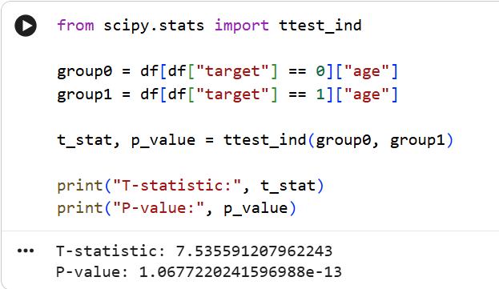
B Chi-Square Test (Sex vs Disease)
Hypothesis
H0: Sex and heart disease are independent
H1: Sex and heart disease are associated

C.Logistic Regression (Main Model)
p-values
Significant variables
Model significance
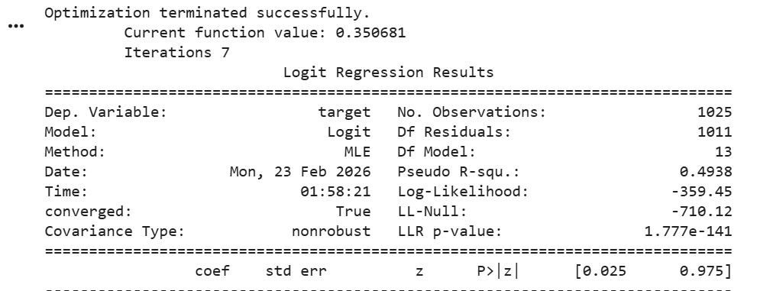
Final Interpretation
The independent t-test revealed a statistically significant difference in age between patients with and without heart disease (t = 7.53, p < 0.05). The chi-square test showed a strong association between sex and heart disease (χ² = 78.86, p < 0.05). Logistic regression analysis further confirmed that the overall model is statistically significant (LLR p-value < 0.001), indicating that clinical predictors significantly influence the probability of heart disease. The pseudo R² value of 0.4938 suggests that the model explains approximately 49% of the variation in heart disease outcomes. Therefore, the null hypotheses were rejected, validating the significance of the selected predictors.

